**TERMWORK 3**

Name : Spoorti Anantapur

USN : 2GI20CS157

DISTANCE VECTOR ROUTING ALGORITHM

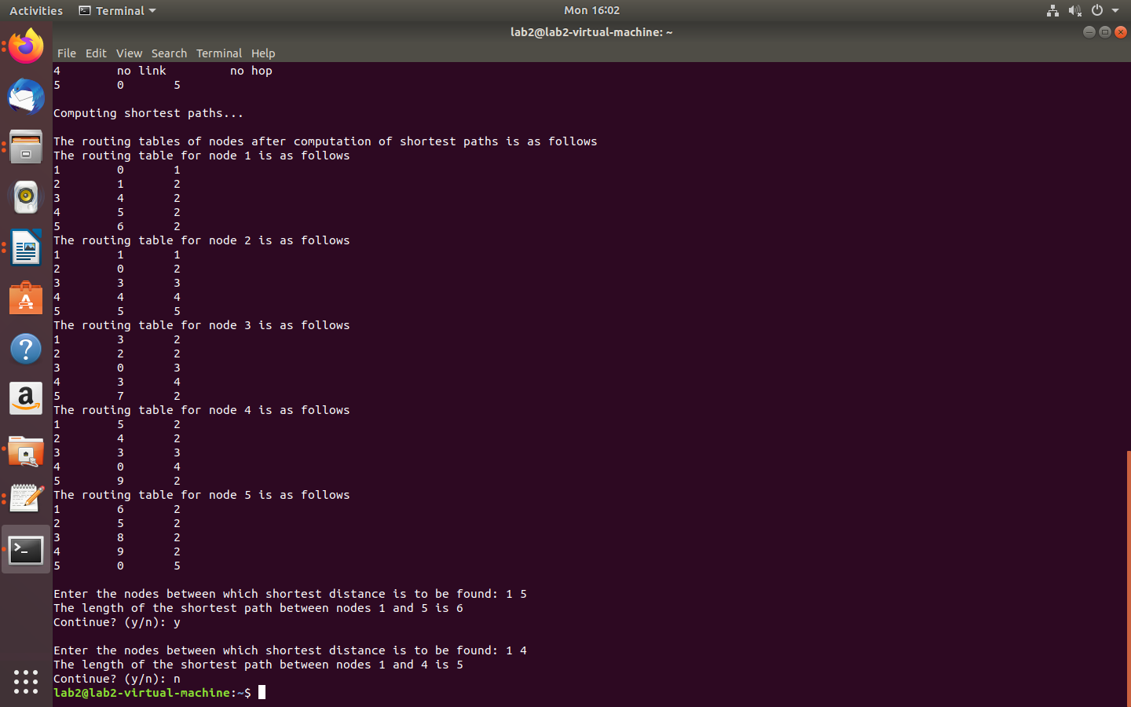

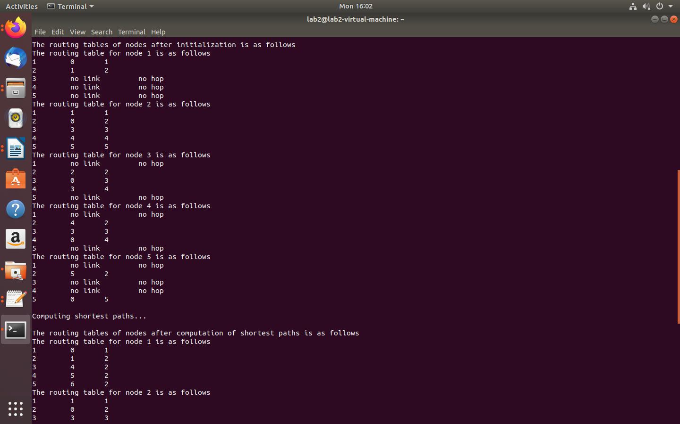

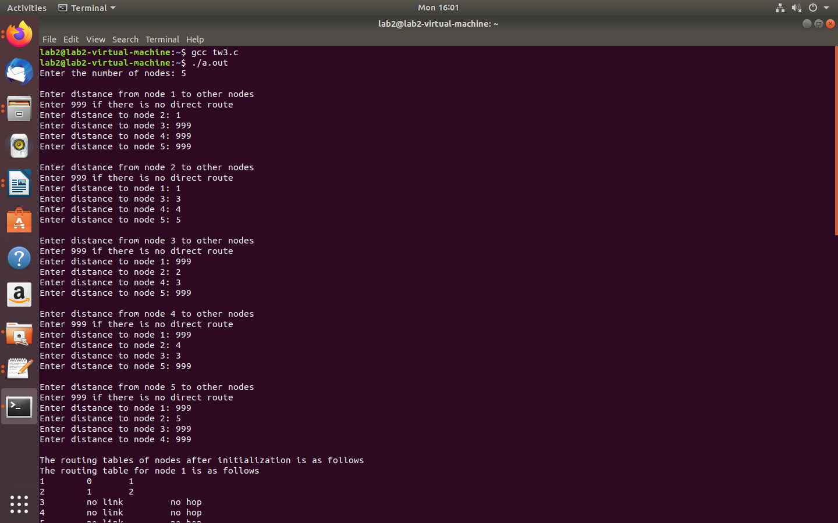

**TERMWORK 4**

Name : Spoorti Anantapur

USN : 2GI20CS157

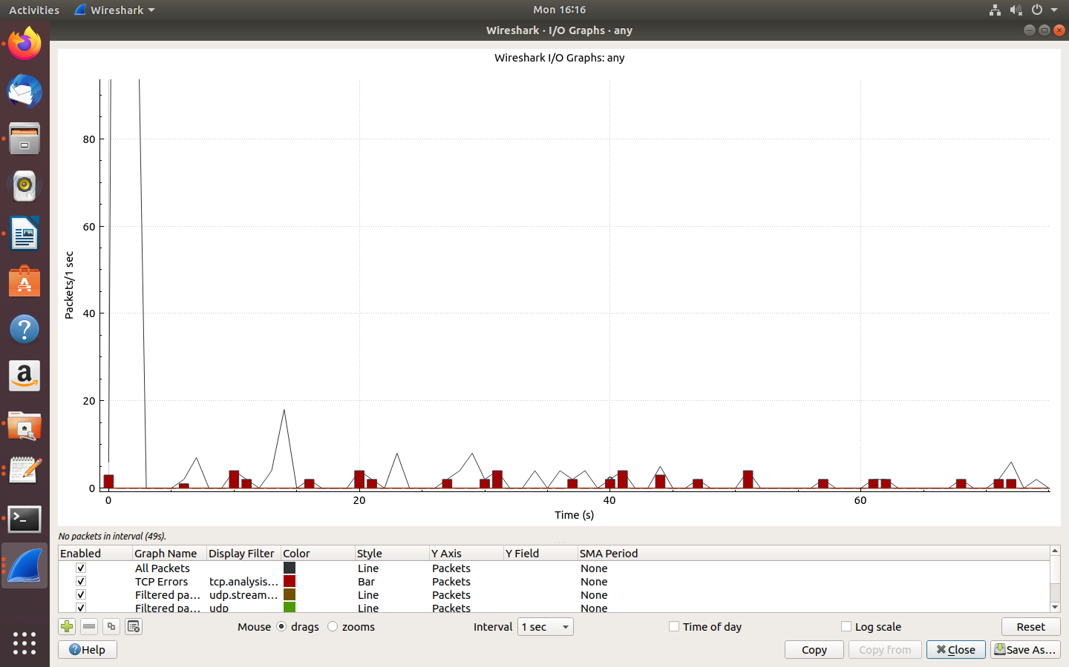Using WIRESHARK observe the data transferred in client server communication using UDP and identify the UDP datagram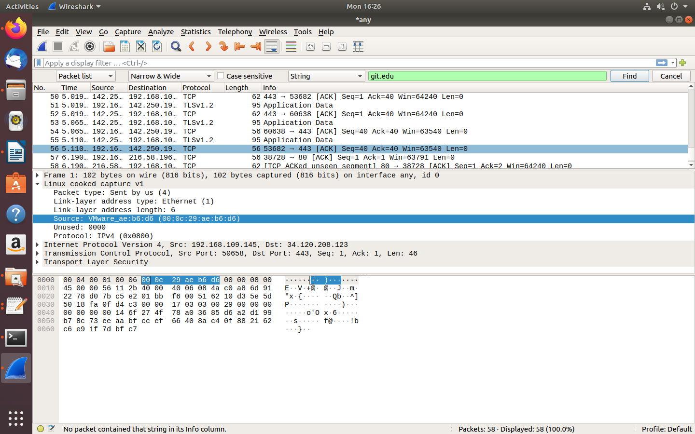

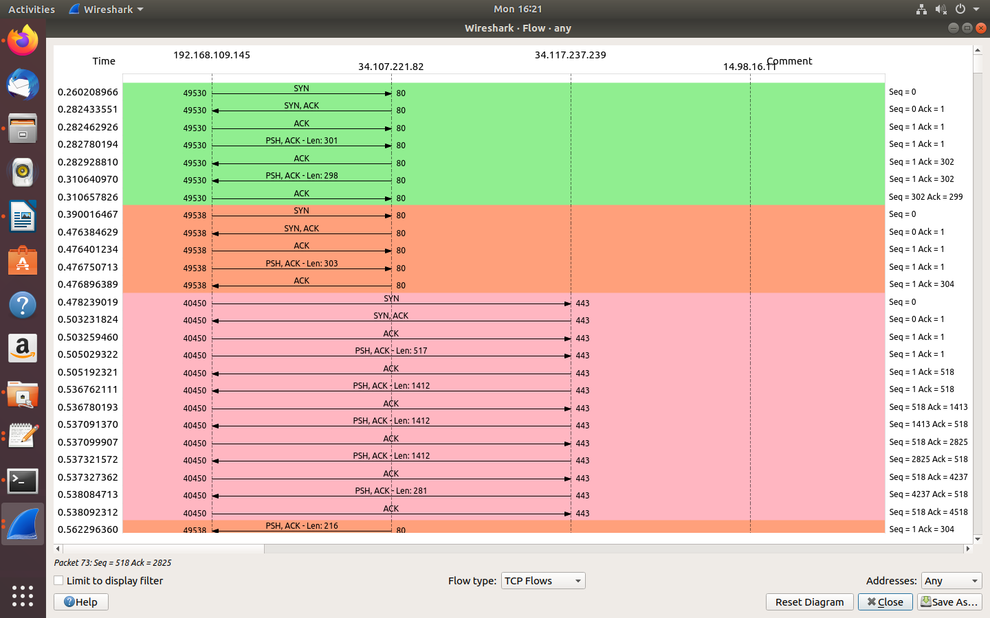

**TERMWORK 5**

Name : Spoorti Anantapur

USN : 2GI20CS157

Using WIRESHARK analyse three way handshaking connection establishment, data transfer and connection termination in client server communication using TCP.

